Homework 3

Software Engineering

Grant Baker, Jonah Gilbertson

Exercise 1 Part A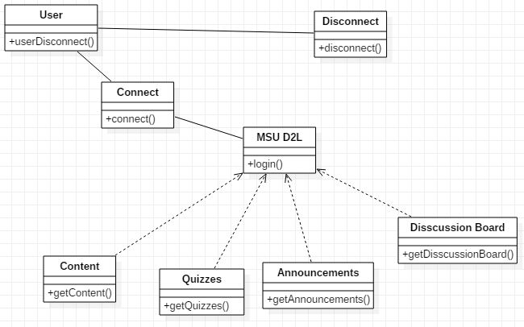

We chose the Command and Observer Pattern. The classes that participate in multiple patterns are MSU D2L. Connect and Disconnect are part of the command strategy by passing in commands to connect or disconnect the user from the Class D2l. The observer pattern are all the classes on D2L that rely on the class. (Content, Quizzes, Announcements, Discussion Board.

Exercise 1 Part B

Command

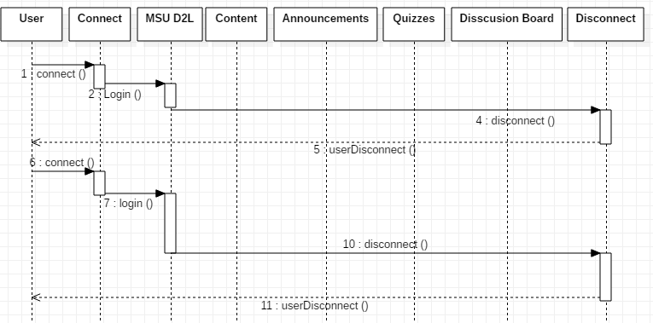

Observer

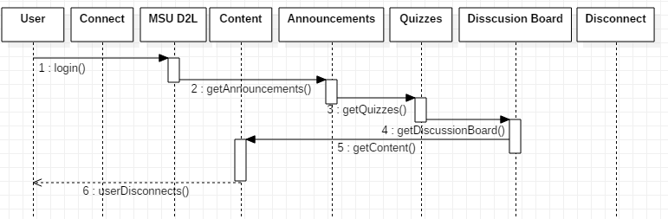

Exercise 2 part A

if 3 people finish 32 story points that's 32/3 = 10.666666 stories a person per sprint so in a 3 week period of time for 4.8 people (because one works 80%) that should be   
10.66666 \* 4.8 = 51.199999 story points for 4.8 people with 1 sprint

Exercise 2 part B

Focus Factor = velocity /(# of team members \* productive days)

51.199999 /( 5\*15) = .682

Estimated Focus Factor of new team would be = .682

Exercise 2 part C

Another way to estimate story points is to have the most experienced team member decide the difficulty of each story and assign the correlating amount of points. This is a worse method than poker because the user doesn’t necessarily have the same experience per-task which could skew the amount of story points users are getting.

Exercise 2 part D

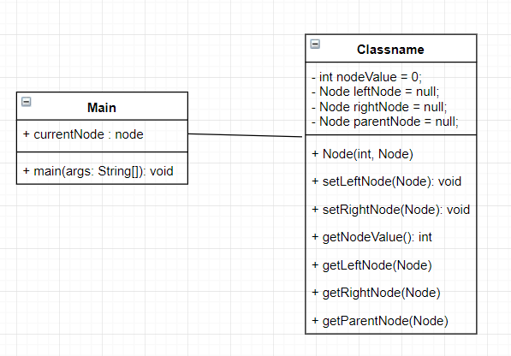

Exercise 2 part E

public class main {

public static void main(String[] args) {

//main method to show how to use linked list

//setting current node passing in the nodes value 1 with a null parent

Node currentNode = new Node(1, null);

//setting the left node by running setLeftNode and creating node with value 2

currentNode.setLeftNode(new Node(2,currentNode));

//setting the right node by running setRightNode and creating node with value 3

currentNode.setRightNode(new Node(3,currentNode));

//should print 1 by getting the current nodes value

System.out.println(currentNode.getNodeValue());

//setting current node to left child

currentNode = currentNode.getLeftNode();

//should print 2 by getting the currentNodes value

System.out.println(currentNode.getNodeValue());

//set current node back to root node

currentNode = currentNode.getParentNode();

//setting current node to right child

currentNode = currentNode.getRightNode();

//should print 3 by getting the currentNodes value

System.out.println(currentNode.getNodeValue());

}

}

public class Node{

//initializing variables nodeValue and left and right nodes

private int nodeValue = 0;

private Node leftNode = null;

private Node rightNode = null;

private Node parentNode = null;

//constructor setting nodevalue

public Node(int nodeVal, Node parent){

nodeValue = nodeVal;

parentNode = parent;

}

//function to set the leftNode

public void setLeftNode(Node node) {

leftNode = node;

}

//function to set the rightNode

public void setRightNode(Node node) {

rightNode = node;

}

//function to get the nodes value

public int getNodeValue(){

return nodeValue;

}

//function to get the left nodes

public Node getLeftNode(){

return leftNode;

}

//function to get the nodes

public Node getRightNode(){

return rightNode;

}

public Node getParentNode(){

return parentNode;

}

}

Exercise 2 part F

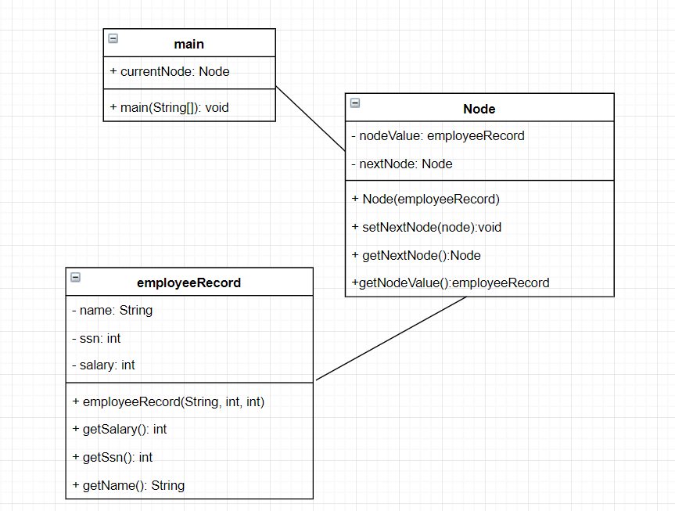

Exercise 2 part G

public class main {

public static void main(String[] args) {

//main method to show how to use linked list

//setting current node passing in the nodes value with greg's employee record

Node currentNode = new Node(new EmployeeRecord("greg", 123456789, 40000));

//setting the next node by running setNextNode and creating node with steve's employee record

currentNode.setNextNode(new Node(new EmployeeRecord("steve", 923456789, 100000)));

//setting the 3rd node by running setNextNode and creating node with value mike's employee record

currentNode.getNextNode().setNextNode(new Node(new EmployeeRecord("mike", 555555555, 20000)));

//should print greg's name

System.out.println(currentNode.getNodeValue().getName());

//utilized linked list by getting following node in list and setting to currentNode

currentNode = currentNode.getNextNode();

//should print steve's SSN

System.out.println(currentNode.getNodeValue().getSsn());

//utilized linked list by getting following node in list and setting to currentNode

currentNode = currentNode.getNextNode();

//should print mike's salary

System.out.println(currentNode.getNodeValue().getSalary());

}

}

public class Node{

//initializing variables nodeValue and nextNode

private EmployeeRecord nodeValue

private Node nextNode = null;

//constructor setting nodevalue

public Node(EmployeeRecord nodeVal){

nodeValue = nodeVal;

}

//function to set the next node

public void setNextNode(Node node) {

nextNode = node;

}

//function to get the next node

public Node getNextNode() {

return nextNode;

}

//function to get the nodes value

public EmployeeRecord getNodeValue(){

return nodeValue;

}

}

public class EmployeeRecord{

//initializing variables

private String name;

private int ssn;

private int salary;

//constructor taking in the name SSN and salary

public EmployeeRecord(String n, int s, int sal){

name = n;

ssn = s;

salary = sal;

}

//method to get salary

public int getSalary() {

return salary;

}

//method to get ssn

public int getSsn() {

return ssn;

}

//method to get name

public String getName() {

return name;

}

}